 |  |  | PURCHASE ORDER
Po no: 25-26 Q Spraynoz Technologies Private Limited206 |  |  |  |  |  | Date: 17-07-2025
Supplier Spraynoz Technologies Private Limited |  |  |  |  |  | Quotation: Verbal
Billing Address: A1, Haritaras Siddharud Sadan, Altinho Rd
 |  | St-inez Panaji - Goa 403001
Shipping Address: 114, Gera Imperium Green, Next to
 |  | Jairam complex, Mala Panaji Goa 403001

SR. NO | Part number | Product Description | Image | Quantity | Pricing Per Unit | Total
1 | 772264 | Spray Nozel with flow capacity GPM at 40 PSI should be 39.85 presure bar should be maintained as per attachemnt | 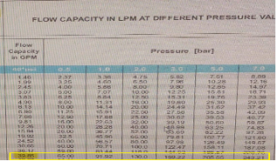 | 30 | 780 | 23,400.00
Total |  |  |  |  |  | 23,400.00
GST 18% |  |  |  |  |  | 4,212.00
Grand Total |  |  |  |  |  | 27,612.00

Terms and conditions apply as per norms JPT001
Kindly dispatch the material as per quotation mentioned
Payment on delivery of the material.

